fs=2000

t=0:1/fs:0.1

fc=1000

fm=20

Ca=cos(2\*pi\*fc\*t)

subplot(3,1,1)

plot(t,Ca)

title('carrier signal')

Fm=cos(2\*pi\*fm\*t)

subplot(3,1,2)

plot(t,Fm)

title('message signal')

AMOD=cos(2\*pi\*fc\*t)+(0.25)\*cos(2\*pi\*(fc+fm)\*t)+(0.250)\*cos(2\*pi\*(fc-fm)\*t)

subplot(3,1,3)

plot(t,AMOD)

title('modulated signal')

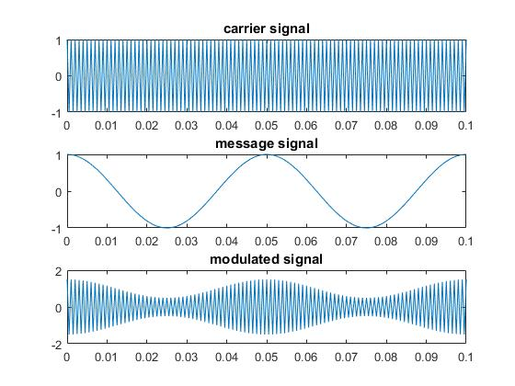

fs=2000

t=0:1/fs:0.1

fc=1000

fm=20

Ca=cos(2\*pi\*fc\*t)

subplot(3,1,1)

plot(t,Ca)

title('carrier signal')

Fm=cos(2\*pi\*fm\*t)

subplot(3,1,2)

plot(t,Fm)

title('message signal')

AMOD=(0.25)\*cos(2\*pi\*(fc+fm)\*t)+(0.250)\*cos(2\*pi\*(fc-fm)\*t)

subplot(3,1,3)

plot(t,AMOD)

title('modulated signal')

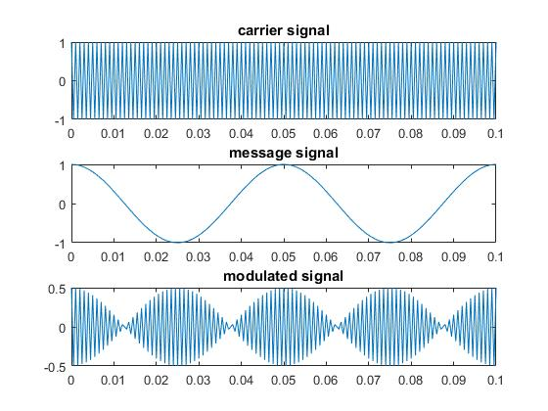

fs=2000

t=0:1/fs:0.1

fc=1000

fm=20

Ca=cos(2\*pi\*fc\*t)

subplot(3,1,1)

plot(t,Ca)

title('carrier signal')

Fm=cos(2\*pi\*fm\*t)

subplot(3,1,2)

plot(t,Fm)

title('message signal')

AMOD=(0.25)\*cos(2\*pi\*(fc+fm)\*t)

subplot(3,1,3)

plot(t,AMOD)

title('modulated signal')

